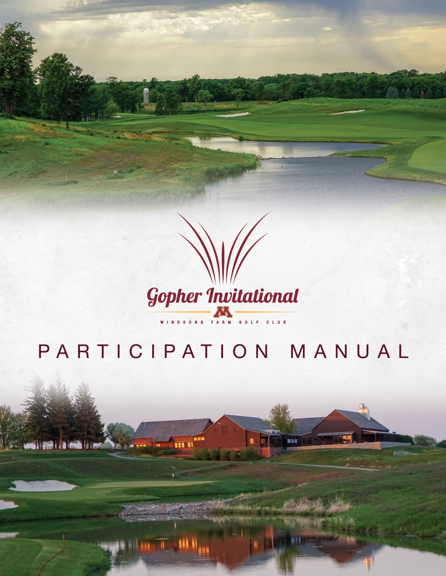

Gopher Invitational Staff

Gopher Invitational Tournament Committee:
Jusitn Smith, Tournament Director
Matt Rachey, Men’s Golf Assistant Coach
Matt Kleinbrook, Windsong Farm GC Head Golf Professional
Jon Dailing, Windsong Farm GC Director of Agronomy
Doug Hoffmann, MGA Rules and Competitions Director
Todd Kraft, Volunteer Coordinator
Karl Anderson, Golfstat Coordinator
Keith Rachey, Sponsorship Coordinator
Grady Meyer, Tournament Coordinator

Gopher Invitational Games Committee:
Doug Hoffmann, MGA Rules and Competitions Director
Matt Kleinbrook, Windsong Farm GC Head Golf Professional
Connor Tanberg, Windsong Farm GC Assistant Golf Professional

Minnesota Men’s Golf Staff:
Justin Smith, Head Coach
Matt Rachey, Assistant Coach
Dusty Clements, Sport Administator
Jacqueline Hoak, Academics
Jenaye Coleman, Compliance
Curtis Simondet, Sports Medicine
Tim McCleary, Business Office
Kristin Zdanczewicz, Strength and Conditioning
Sarissa Falk, Administrative Specialist
Karl Anderson, Communications

2020 Gopher Invitational Field

ARKANSAS

KANSAS

IOWA

FURMAN

FLORIDA

NOTRE DAME

MICHIGAN STATE

MINNESOTA

MIAMI (OH)

GEORGIA SOUTHERN

PURDUE

COLLEGE OF CHARLESTON

WEST VIRGINIA

ARKANSAS STATE

Schedule of Events

Friday, September 11
ALL DAY Teams Arrive and Check In at Hotel
Saturday, September 12
-Breakfast on Your Own-
9:45 a.m. Practice facilities open
11:00 a.m. Practice round tee times
10:30 a.m.-1:00 p.m. Lunch-clubhouse
2:00-2:30 p.m. Coaches meeting-clubhouse
7:00 p.m. Practice areas close
-Dinner on Your Own-

Sunday, September 13
5:50-8:50 a.m. Breakfast-Windsong Farm Golf Club
6:15 a.m Practice facilities open
7:15 a.m. 1st Round Tee Times Start
11:30 a.m.-1:00 p.m. Box lunches available-clubhouse
12:30 p.m. Continuous Play
6:00-8:00 p.m. Dinner-clubhouse

Monday, September 14
5:50-8:50 a.m. Breakfast-Windsong Farm Golf Club
6:15 a.m. Practice facilities open
*7:15 a.m. Final round Tee Times off #1 and #10
12:00-2:30 p.m. Buffet lunch-Windsong Farm Golf Club
2:30 p.m. Awards Ceremony

*In the case of weather delays, shotgun start would take place at 9:00 am.

Practice Round Times

Hole #1

11:00 a.m. University of Minnesota
11:10 a.m. University of Minnesota
11:20 a.m. Michigan State University
11:30 a.m. University of Arkansas
11:40 a.m. University of Iowa
11:50 a.m. Arkansas State University
12:00 p.m. Miami (OH) University
12:10 p.m. Kansas University
12:20 p.m. Furman University
12:30 p.m. Georgia Southern University
12:40 p.m. Purdue University
12:50 p.m. University of Notre Dame
1:00 p.m. West Virginia University
1:10 p.m. College of Charleston
1:20 p.m. University of Florida

Competition Tee Times

ROUND 1: Sunday, September 8

Hole #1---
7:15-7:55 a.m. Michigan State, Iowa, Purdue
8:05-8:45 a.m. Minnesota, Notre Dame, Arkansas
8:55-9:35 a.m. West Virginia, Arkansas State, Florida

Hole #10--- NOTE DIFFERENCE IN 1st TIME FROM TEE #1
7:30-8:18 a.m. College of Charleston, Miami (OH), Kansas
8:30-9:18 a.m. Georgia Southern, Furman, Minnesota Individuals

ROUND 2: Sunday, September 8

Continuous Play.

FINAL ROUND: Monday, September 9

Hole #1—
7:15-7:55 a.m. Teams #7, #8, #9
8:05-8:45 a.m. Teams #4, #5, #6
8:55-9:35 a.m. Teams #1, #2, #3

Hole #10— NOTE DIFFERENCE IN 1st TIME FROM TEE #1
7:30-8:18 a.m. Teams #10, #11, #12
8:30-9:18 a.m. Teams #13, #14, Minnesota Individuals

General Information

Lineups
Email Coach Smith (smit1586@umn.edu) at earliest convenience.

Entry Fee
There is NO entry fee for the 2020 Gopher Invitational.

Breakfast
Saturday-On your own. Hotel has breakfast at a cost and see restaurant suggestion page for additional options.
Sunday/Monday-Breakfast available at Windsong Farm GC for $20/person. Credit cards and cash are both acceptable forms of payment.

Additional Meals
Lunch will be provided Saturday, Sunday and Monday at golf course. Dinner will be served on Sunday following play. Dinner on your own Friday and Saturday night.

Parking

No assigned parking spots at Windsong Farm GC in 2020. Park anywhere in the main lot at Windsong Farm GC

Rules Officials & Committee
The rules officials for the Gopher Invitational will be from the Minnesota Golf Association. The rules committee is comprised of Doug Hoffman, Rules and Competitions Director of MGA, and additional staff. 10-15 rules officials will be on site daily.

Pace of Play
Pace of play policy will be handed out at the coaches meeting.

Spectators
Spectators are encouraged to attend however will be asked to maintain an appropriate distance (15 feet) from the participants. Spectators will not be given golf carts unless permission is granted through medical waiver. Carts are limited for the event. Please contact Matt Kleinbrook, Windsong Farm Golf Club Head Professional, to make special arrangements. Pro Shop telephone # is (763) 479-3535.

Live Scoring
Hole-by-Hole walking scorers will be with each group for all 3 rounds. Scoring will be available at Golfstat.com.

Sports Medicine
The training staff will offer onsite services throughout the tournament and will be located at the back of the men’s locker room. A daily schedule and contact information for the trainer will be provided at the coaches’ meeting.

Awards
The winning team members and individual medalist will be awarded trophies immediately following play next to the scoreboard in the staging area. Additional trophies will be handed out for 2nd and 3rd place individuals.

Coaches Meeting
The coaches meeting will take place at 2:00 pm in the Windsong Farm dining room. We ask all coaches to be respectful of other coaches’ time and to arrive 5 minutes prior. Doug Hoffmann will be conducting meeting. Please allow 30 minutes for meeting.

LOCAL DINING OPTIONS

Breakfast:
**Benedict’s-845 Lake Street East, Wayzata
*Maggies-844 Lake Street East, Wayzata
*Panera Bread-12967 Ridgedale Drive, Minnetonka

Dinner:
***BLVD Kitchen-11544 Wayzata Blvd, Minnetonka
***Bacio-1571 Plymouth Road, Minnetonka
***Birch’s on the Lake-1310 West Wayzata Blvd, Long Lake
**Champps-1641 Plymouth Road, Minnetonka
***COV-700 Lake Street East, Wayzata
***Crave-1603 West End Blvd, St. Louis Park
****Gianni’s Steakhouse-635 Lake Street East, Wayzata
***6Smith-294 Grove Lane East, Wayzata

Prices/Person:
*$5-$10
**$11-$20
***$21-$30
****$30+

THANK YOU CONTACTS

Gopher Invitational Tournament Committee:

Justin Smith and Matt Rachey
516 15th Avenue SE
Suite 240G
Minneapolis, MN 55455

Matt Kleinbrook and Jon Dailing
18 Golf Walk
Independence, MN 55359-6200

Doug Hoffmann
6550 York Avenue South #211
Edina, MN 55435

