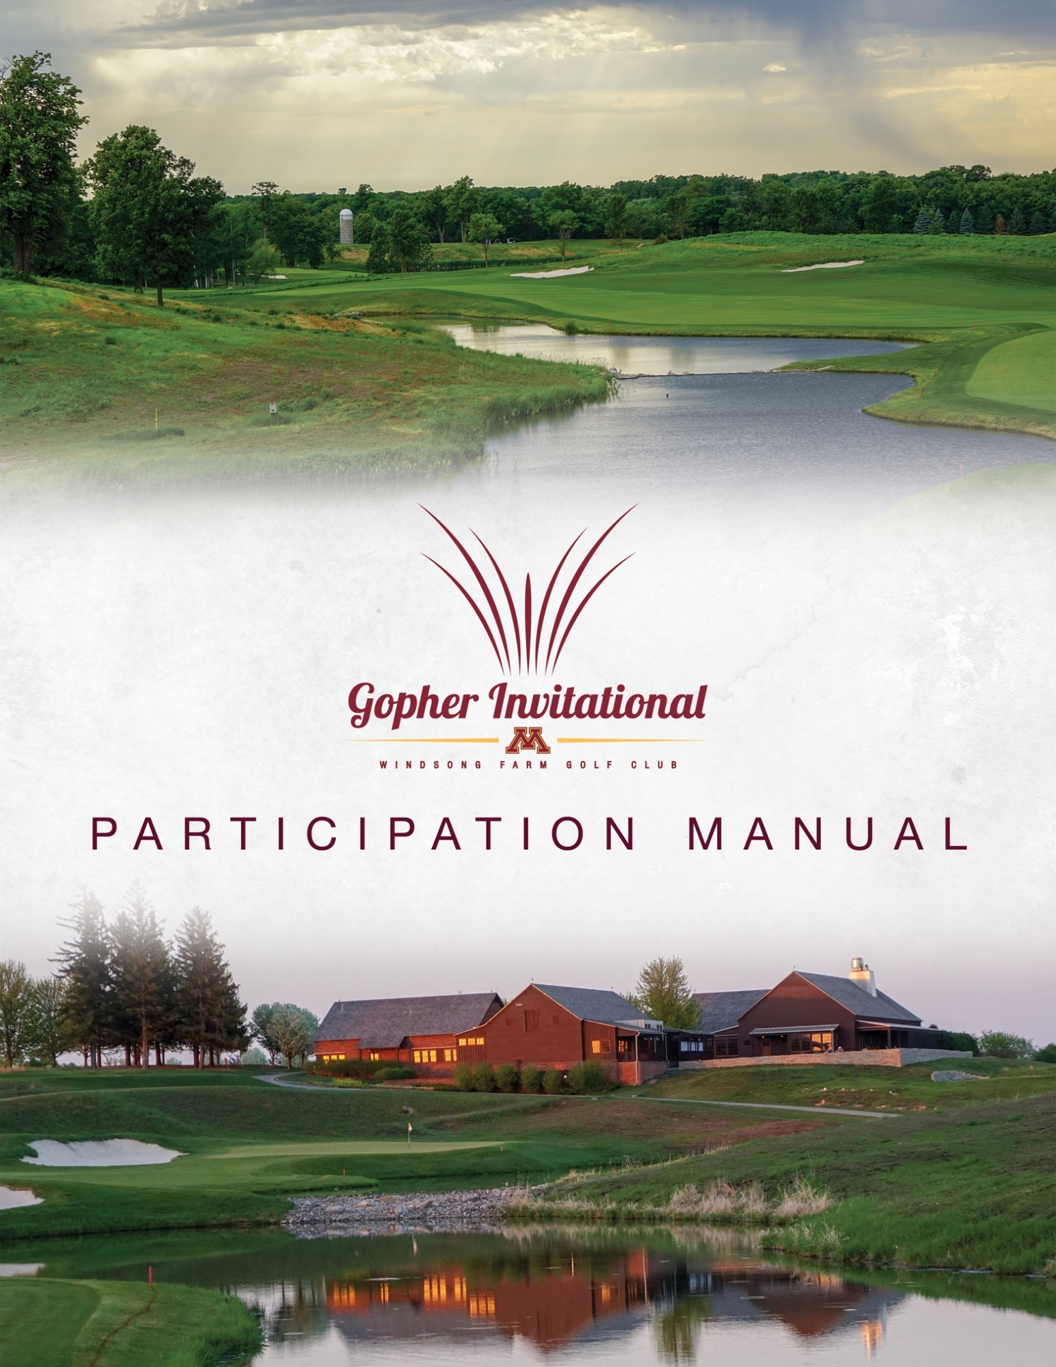

Gopher Invitational Staff

Gopher Invitational Tournament Committee:
Justin Smith, Men’s Golf Head Coach
Matt Rachey, Men’s Golf Assistant Coach
Matt Kleinbrook, Windsong Farm GC Head Golf Professional
Paul Glynn, Windsong Farm GC Director of Operations
Jon Dailing, Windsong Farm GC Superintendent
Doug Hoffmann, MGA Rules and Competitions Director
Todd Kraft, Volunteer Coordinator
Sadie Keller, Golfstat Coordinator
Keith Rachey, Sponsorship Coordinator

Gopher Invitational Games Committee:
Doug Hoffmann, MGA Rules and Competitions Director
Matt Kleinbrook, Windsong Farm GC Director of Golf
Connor Tanberg, Windsong Farm GC Head Golf Professional

Minnesota Men’s Golf Staff:
Justin Smith, Head Coach
Matt Rachey, Assistant Coach
Mike Wierzbicki, Men’s Golf Sport Administrator
Jacqueline Hoak, Academics
Aaron Berens, Compliance
Adam Bates, Equipment
Curtis Simondet, Sports Medicine
Elizabeth Antol, Business Office
Kristin Zdanczewicz, Strength and Conditioning
Sadie Keller, SID Men’s Golf

2021 Gopher Invitational Field

FURMAN

NOTRE DAME

ARKANSAS STATE

GEORGIA SOUTHERN

MIAMI (OH)

IOWA STATE

KANSAS

MICHIGAN STATE

WEST VIRGINIA

RUTGERS

KENT STATE

MARQUETTE

IOWA

MINNESOTA

Schedule of Events

Friday, September 10
ALL DAY Teams Arrive and Check In at Hotel
Saturday, September 11
-Breakfast on Your Own-
10:00 a.m. Practice facilities open
11:00 a.m. Practice round tee times
10:30 a.m.-1:00 p.m. Lunch-clubhouse
2:00-2:30 p.m. Coaches meeting-clubhouse
7:00 p.m. Practice areas close
-Dinner on Your Own-

Sunday, September 12
6:00-8:50 a.m. Breakfast-Windsong Farm Golf Club
- $20/person payable by Credit Card
6:15 a.m Practice facilities open
7:15 a.m. 1st Round Tee Times Start
11:30 a.m.-1:00 p.m. Box lunches available-clubhouse
12:30 p.m. 2nd Round - Continuous Play
6:00-8:00 p.m. Dinner-clubhouse

Monday, September 13
6:00-8:50 a.m. Breakfast-Windsong Farm Golf Club
- $20/person payable by Credit Card
6:15 a.m. Practice facilities open
*7:15 a.m. Final round Tee Times off #1 and #10
12:00-2:30 p.m. Lunch-Windsong Farm Golf Club
2:30 p.m. Awards Ceremony

*In the case of weather delays, shotgun start would take place at 9:00 am.

Practice Round Times

Hole #1

11:00 a.m. University of Minnesota
11:10 a.m. University of Minnesota
11:20 a.m. Michigan State University
11:30 a.m. Iowa State University
11:40 a.m. University of Iowa
11:50 a.m. Arkansas State University
12:00 p.m. Miami (OH) University
12:10 p.m. Kansas University
12:20 p.m. Kent State University
12:30 p.m. Marquette University
12:40 p.m. University of Notre Dame
12:50 p.m. West Virginia University
1:00 p.m. Rutgers University
1:10 p.m. Georgia Southern University
1:20 p.m. Furman University

Competition Tee Times

ROUND 1: Sunday, September 12

Hole #1---
7:15-7:55 a.m. Georgia Southern, Marquette, Notre Dame
8:05-8:45 a.m. Minnesota, Michigan State, Iowa State
8:55-9:35 a.m. West Virginia, Arkansas State, Iowa

Hole #10--- NOTE DIFFERENCE IN 1st TIME FROM TEE #1
7:30-8:18 a.m. Miami (OH), Kansas, Kent State
8:30-9:18 a.m. Rutgers, Furman, Minnesota Individuals

ROUND 2: Sunday, September 12

Continuous Play.

FINAL ROUND: Monday, September 13

Hole #1—
7:15-7:55 a.m. Teams #7, #8, #9
8:05-8:45 a.m. Teams #4, #5, #6
8:55-9:35 a.m. Teams #1, #2, #3

Hole #10— NOTE DIFFERENCE IN 1st TIME FROM TEE #1
7:30-8:18 a.m. Teams #10, #11, #12
8:30-9:18 a.m. Teams #13, #14, Minnesota Individuals

General Information

Lineups
Email Coach Smith (smit1586@umn.edu) at earliest convenience.

Entry Fee
There is NO entry fee for the 2021 Gopher Invitational.

Breakfast
Saturday-On your own. Hotel has breakfast at a cost and see restaurant suggestion page for additional options.
Sunday/Monday-Breakfast available at Windsong Farm GC for $20/person. Teams are responsible for each breakfast. Credit card payments only due to updated Covid protocols. At your earliest convenience, please email Coach Smith, smit1586@umn.edu to note whether you intend to utilize the breakfast at Windsong Farm each day.

Additional Meals
Lunch will be provided Saturday, Sunday (box lunches) and Monday at golf course. Dinner will be served on Sunday following play. Dinner on your own Friday and Saturday night.

Parking

No assigned parking spots at Windsong Farm GC in 2021. Park anywhere in the main lot at Windsong Farm GC

Rules Officials & Committee
The rules officials for the Gopher Invitational will be from the Minnesota Golf Association. The rules committee is comprised of Doug Hoffmann, Rules and Competitions Director of MGA, and additional staff. 8-10 rules officials will be on site daily.

Pace of Play
Pace of play policy will be handed out at the coaches meeting.

Spectators
Spectators are encouraged to attend however will be asked to maintain an appropriate distance (15 feet) from the participants according to NCAA guidelines. Spectators will not be given golf carts unless permission is granted through medical waiver. Carts are limited for the event. Please contact Matt Kleinbrook, Windsong Farm Golf Club Head Professional, to make special arrangements. Pro Shop telephone # is (763) 479-3535. Windsong Farm Golf Club will make final determination on golf cart usage.

Live Scoring
Hole-by-Hole walking scorers will be with each group for all 3 rounds. Scoring will be available at Golfstat.com.

Sports Medicine
The training staff will offer onsite services throughout the tournament and will be located at the back of the men’s locker room. A daily schedule and contact information for the trainer will be provided at the coaches’ meeting.

Awards
The winning team members and individual medalist will be awarded trophies immediately following play next to the scoreboard in the staging area. Additional trophies will be handed out for 2nd and 3rd place individuals.

Coaches Meeting
The coaches meeting will take place at 2:00 pm on Saturday September 11 in the Windsong Farm dining room. We ask all coaches to be respectful of other coaches’ time and to arrive 5 minutes prior. Doug Hoffmann will be conducting meeting. Please allow 30 minutes for meeting.

LOCAL DINING OPTIONS

Breakfast:
**Benedict’s-845 Lake Street East, Wayzata
*Maggies-844 Lake Street East, Wayzata
*Panera Bread-12967 Ridgedale Drive, Minnetonka
*Coffee and Bagels-1700 Plymouth Rd, Minnetonka

Dinner:
**The Cheesecake Factory-12735 Wayzata Blvd, Minnetonka
**The Loop West End-5331 W 16th St, Minneapolis
**Yard House-1665 Park Place Blvd, St. Louis Park
***BLVD Kitchen-11544 Wayzata Blvd, Minnetonka
***Bacio-1571 Plymouth Road, Minnetonka
***Birch’s on the Lake-1310 West Wayzata Blvd, Long Lake
***COV-700 Lake Street East, Wayzata
***Crave-1603 West End Blvd, St. Louis Park
***6Smith-294 Grove Lane East, Wayzata

Prices/Person:
*$5-$10
**$11-$20
***$21-$30

THANK YOU CONTACTS

Gopher Invitational Tournament Committee:

Justin Smith and Matt Rachey
516 15th Avenue SE
Suite 260
Minneapolis, MN 55455

Paul Glynn, Matt Kleinbrook, and Jon Dailing
18 Golf Walk
Independence, MN 55359-6200

David Meyer – Owner of Windsong Farm Golf Club
18 Golf Walk
Independence, MN 55359-6200

Doug Hoffmann
6550 York Avenue South #211
Edina, MN 55435

